RTG Visual Studio Automation Framework

Document Control
Process | Name | Title | Date
Authored by | Webber Ling | Team Lead, Quality Assurance | Aug 10, 2015
Approved by

Revision History
Date | Version | Description | Author
Aug 10, 2015 | 1.0 | Initial version | Webber Ling

RTG Visual Studio Automation Framework
Table of Contents
Contents
1. Introduction - 2 -
1.1 RTG Visual Studio Automation Framework - 2 -
2. Reference - 2 -
3. Purpose - 2 -
3.1 Purpose of RTG Retirement Studio Automation Framework - 2 -
4. RTG Visual Studio Automation Framework - Folder Structure - 3 -
4.1 Description - 3 -
4.2 RTG Visual Studio automation Framework - folder structure - 3 -
5. RTG Visual Studio Automation Framework – Multiple Function Library Layer - 4 -
5.1 DESCRIPTION - 4 -
5.2 MULTIPLE FUNCTION LIBRARY LAYER - 4 -
6. RTG Visual Studio Automation Framework – Testing Data Management - 5 -
6.1 Description - 5 -
6.2 Test Data - 5 -
6.3 Reports - 5 -
6.4 Screen Capture - 5 -
6.5 Test Log - 6 -
7. RTG Visual Studio Automation Framework – Work Flow - 6 -
7.1 Description - 6 -
7.2 RTG Visual Studio Automation Framework Work Flow - 6 -

RTG Visual Studio Automation Framework

Introduction

RTG Visual Studio Automation Framework
This document outlines the RTG Visual Studio Automation Framework, which accommodates all AUTs (Application Under Test), BS/CS structure, or different technology, e.g. .Net, Web, VB, Java, C++, etc, which will be used by RTG QA team.
The framework structure defined in this document should be strictly followed because its internal function layer optimizes the complex C# codes implementation for various standard objects. It cuts down the automation engineer training cost, script developing/transferring efforts and maintenance cost as well. And it allows easy expanding for integration testing.

Reference
<RTG Visual Studio Automation Framework – Best Practice.doc> TBC
<RTG Visual Studio Automation Framework – PopVerifyFunciton.doc>

Purpose

Purpose of RTG Retirement Studio Automation Framework
The purpose of this document is to introduce the RTG Visual Studio automation framework which categorized as below:
- RTG Visual Studio Automation Framework – Folder Structure
- RTG Visual Studio Automation Framework – Multiple Function Library Layer
- RTG Visual Studio Automation Framework – Test Data Management
- RTG Visual Studio Automation Framework – Work Flow

RTG Visual Studio Automation Framework - Folder Structure

Description
Automation folder structure defines the physical folder structure for categorizing all testing related files. The folder structure is defined as Generic structure. All scripts, function libraries, documents, log files, object repository, screen captures should be placed under corresponding directory.

RTG Visual Studio automation Framework - folder structure

Physical Folder Structure Visual Studio Project Structure
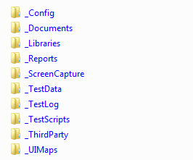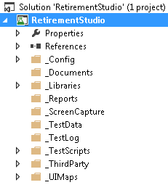

_Config | Configure settings for testing project. Includes all necessary settings for current project.
_Config | For example, testing environment, country, wait time, common object click position, timeout, etc.
_Documents | Places to put testing related documents, for example, Test User Guide, training documents, etc.
_Libraries | Places to put function libraries
_Libraries | By default, it includes 4 libraries: GeneericLib.cs, GenericLib_Web.cs, GenericLib_Win.cs, CompareReportsLib.cs
_Libraries | User can add other custom libraries if necessary
_Reports | Places to put testing generated output reports
_ScreenCapture | Places to put runtime generated screen capture for further reference
_TestData | All testing related input data file should be in this folder
_TestLog | The testing log file will be automatically generated here for debugging purpose
_TestScripts | This is the top level folder to store test scripts, user can add test scripts under this folder directly or generate subfolders with large amount of test scripts which required further categorization
_ThirdParty | Any third party support files should be placed under this folder, e.g. in Retirement Studio, a function lib to support third part control (farpoint) is placed here
_UIMaps | This is the place to organize/categorize UIMap files, all UI map files should under this folder

RTG Visual Studio Automation Framework – Multiple Function Library Layer

DESCRIPTION
The test automation toolset needs to be treated like software development architecture, with reusable modules as part of standard automation frame work.
The multiple function library layers support the basic functions for standard windows controls, standard .Net controls and standard Web controls and object-independent function library.

MULTIPLE FUNCTION LIBRARY LAYER
Overall, there are two categories of function libraries: one is common function library which stores function libraries shared by all AUTs (Generic Lib, .Net Lib, Web Lib, others). Another is AUT specific library which applies to one and only one specific AUT (UI maps and screen functions).
These two categories are defined by the Automation Folder Structure, which is called Physical Category (Lay1 in Libraries folder, Layer2 in UIMaps folder).
The function library layer here is defined by function call logic, which is called Logic Category.
There are three layers (Logic Category) of function libraries which are defined in this framework.

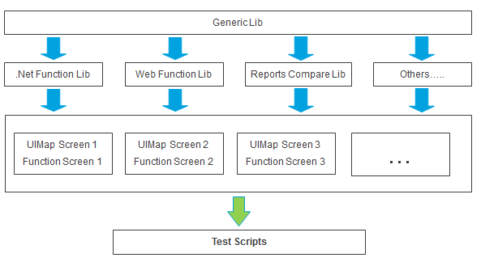

There are three layers of function library. The later one depends on previous one, e.g. Layer 3 depends on Layer 2 which depends on Layer 1.
Layer 1:
This is the bottom layer which can be called by any other function library and can be used by any type of AUT.
For example, file I/O functions, Excel manipulate functions, string compare functions, etc.
Layer 2:
This layer contains libraries for specific type of object, e.g. Web Function Lib defines the very basic methods/functions for Web app objects, for example, WebEdit, WebList, etc. And .Net Function Lib for.Net windows objects. The functions/methods defined in this layer are registered for its own class, which means user can use context menu to browse and select the method using C# codes in Visual Studio.
Both Layer1 and Layer2 are shared by all AUTs.
Layer 3:
This layer is AUT specific function/object library, which means each AUT has its own UIMaps and screen functions, e.g. Retirement Studio is a .Net standard alone application, the user function defined in its corresponding UI Maps and corresponding screen functions.
For each AUT, it has its own layer3 which is based on layer2, layer1.
Finally, the testing script is serials of function calls from Layer3.

RTG Visual Studio Automation Framework – Testing Data Management

Description
Test data management in the document includes all testing related input/output and log data structure and naming convention.
Based on the Folder Structure, there are four directories used to store testing data: _Reports, _ScreenCapture, _TestData, _TestLog

Test Data
All test input data should be placed under _TestData folder using the same name as its corresponding test script name. It could be MS Excel file type or TXT file format or any other type. For example, a test script named “RS_DataStandardCheck001.cs”, which is placed under _TestScripts folder, and its corresponding input data should named as “RS_DataStandardCheck001.xls” and placed under _TestData folder.

Reports
All testing output data files should be placed under this folder. And the naming convention should be applied as well. (The output/log file should use the same name as test script and if multiple output files for single test script is required, need to create a sub folder under Reports folder using the same name as test script.)

Screen Capture
This folder is used to store all runtime screen captures which will be used as reference when test requires further analyze.
As a standard of this framework, each AUT specific function will generate a runtime screen capture using the function name and it is stored in Screen Capture folder.
As a standard workflow of this framework, a monthly or bi-monthly backup of this folder is required to archive all screen captures for further reference.

Test Log
This folder is used to store runtime testing log, something like QTP results file, any single action will be recorded in this txt file, which means it can be used to tracking the testing steps for debugging.
This file will be automatically generated using date time stamp.

RTG Visual Studio Automation Framework – Work Flow

Description
The workflow illustrates the relationship between different components/folders in this automation framework. Test script under _TestScripts folder will be the core of this workflow and rest of components will be directly or indirectly connected to Test Script.

RTG Visual Studio Automation Framework Work Flow
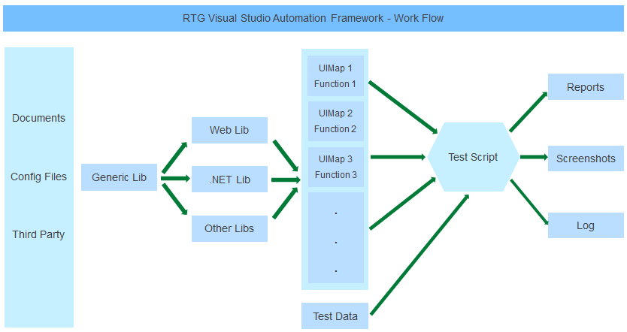
As stated in chapter 5.2, all three function library layers are used to support test script (directly or indirectly), and the test script will generate reports (optional), Screenshots and log files.

